
GREATER TZANEEN MUNICIPALITY
GROTER TZANEEN MUNISIPALITEIT
MASIPALA WA TZANEEN
MASEPALA WA TZANEEN

Tropical Paradise

P.O. BOX 24 TEL: 015 307 8000
TZANEEN FAX: 015 307 8049
0850
www.tzaneen.gov.za

______________________________________________________________

SCHEDULE OF SERVICE DELIVERY STANDARDS TABLE
COMMUNITY SERVICES DEPARTMENT

ENVIRONMENTAL HEALTH SERVICES

- Approval of building plan

1 Day

- Complaint investigation

2 Days
- Issuing of Certificate of Competence for mortuaries

1 Month
- Approval of on-site- waste management plan.
14 days
- Review and comment on Basic Assessment Report.
21 days

SOLID WASTE REMOVAL
- Premise based removal (Residential Frequency)

- Premise based removal (Business Frequency)

- Bulk Removal

- Removal Bags provided (Yes/No)

- Garden refuse removal included (Yes/No)

- Street Cleaning Frequency in CBD

- Street Cleaning Frequency in areas excluding CBD

- How soon are public areas cleaned after events (24hours/48hours/longer)

- Clearing of illegal dumping (24 hours/48hours/longer)

- Recycling or environmentally friendly practices (Yes/No)

- Licensed landfill site (Yes/No)

LICENSING SERVICES
- How long does it take to register a vehicle? (minutes)

10 Minutes per transaction
- How long does it take to renew a vehicle license? (minutes)

10 Minutes per transaction
- How long does it take to issue a duplicate registration certificate vehicle? (minutes)

10 Minutes per transaction

- How long does it take to de-register a vehicle? (minutes)

10 minutes for application and the approval part lies within the Provincial helpdesk

- How long does it take to renew a drivers license? (minutes)

15 Minutes
- What is the average reaction time of the fire service to an incident? (minutes)

Disaster
- What is the average reaction time of the ambulance service to an incident in the urban area? (minutes)

- What is the average reaction time of the ambulance service to an incident in the rural area? (minutes)

LIBRARY SERVICES

- Checking in of library item

2 Minutes
- Checking out of library item

2 Minutes
- Registering membership

10 Minutes
- Assisting with finding project information

10 Minutes
WASTE DIVISION
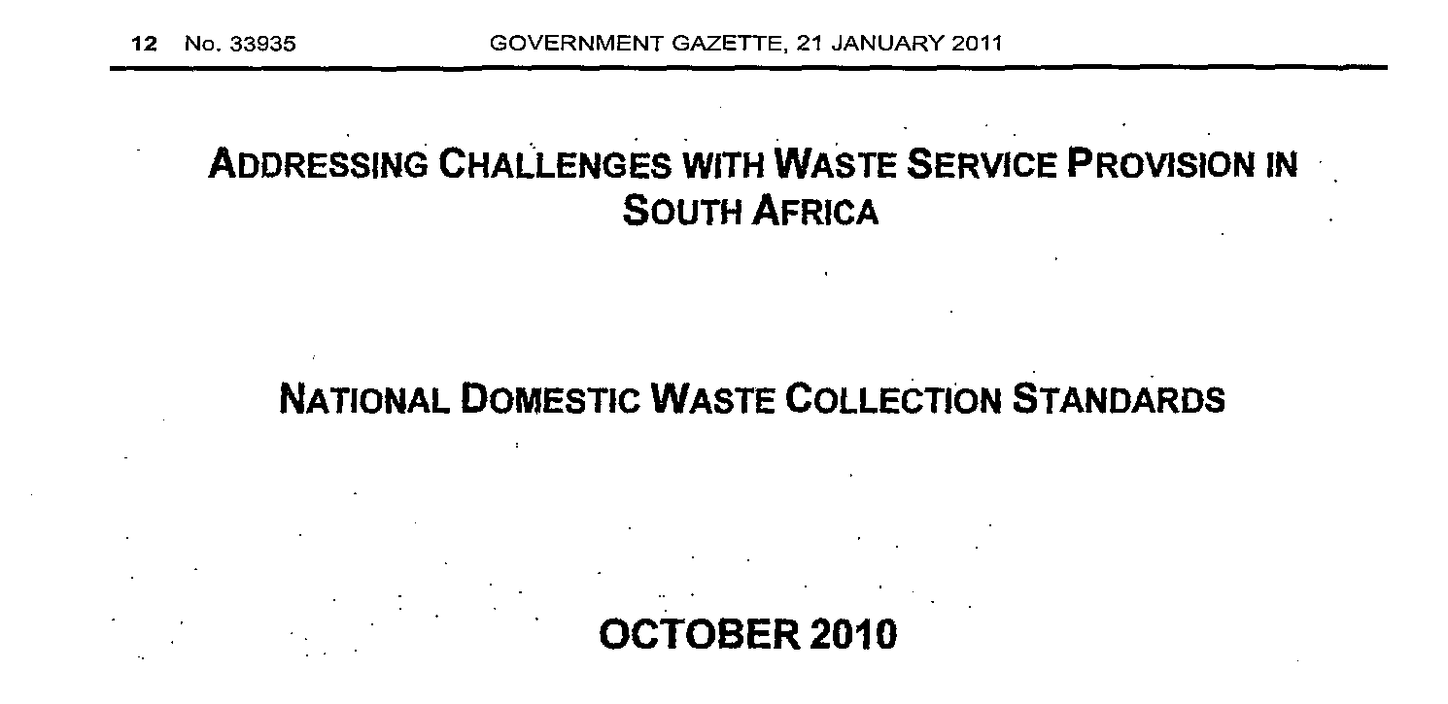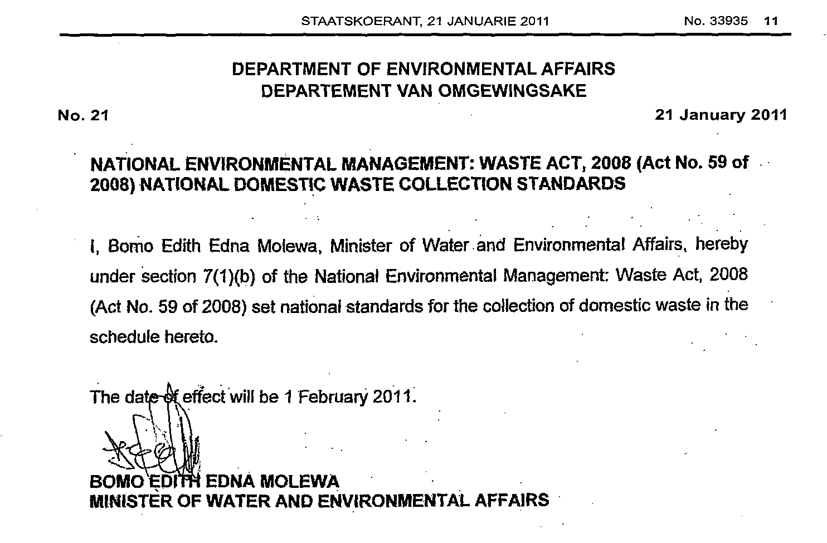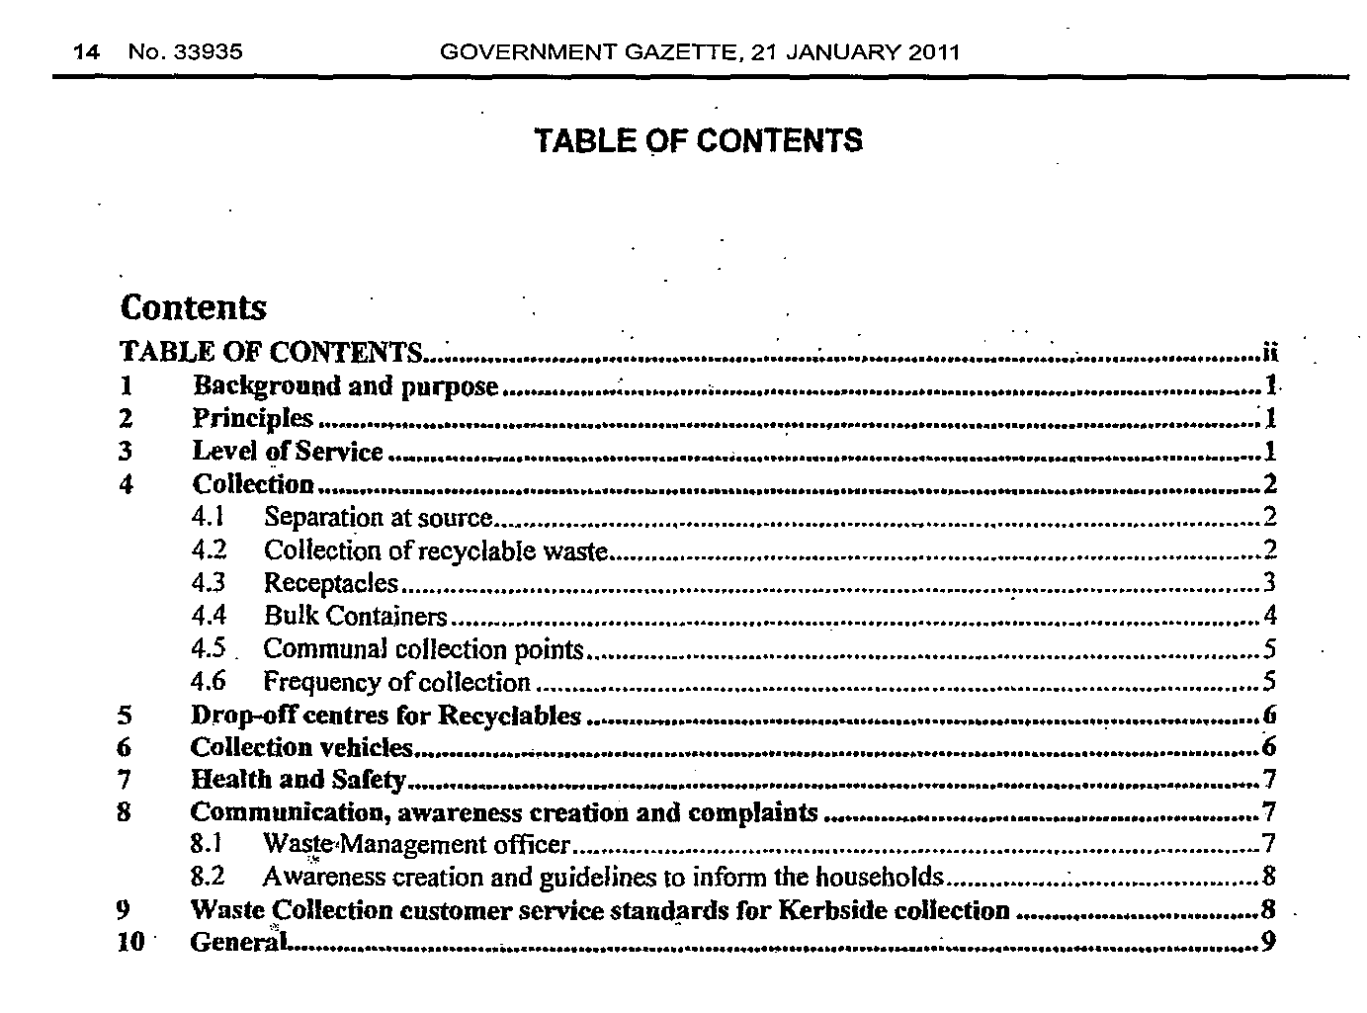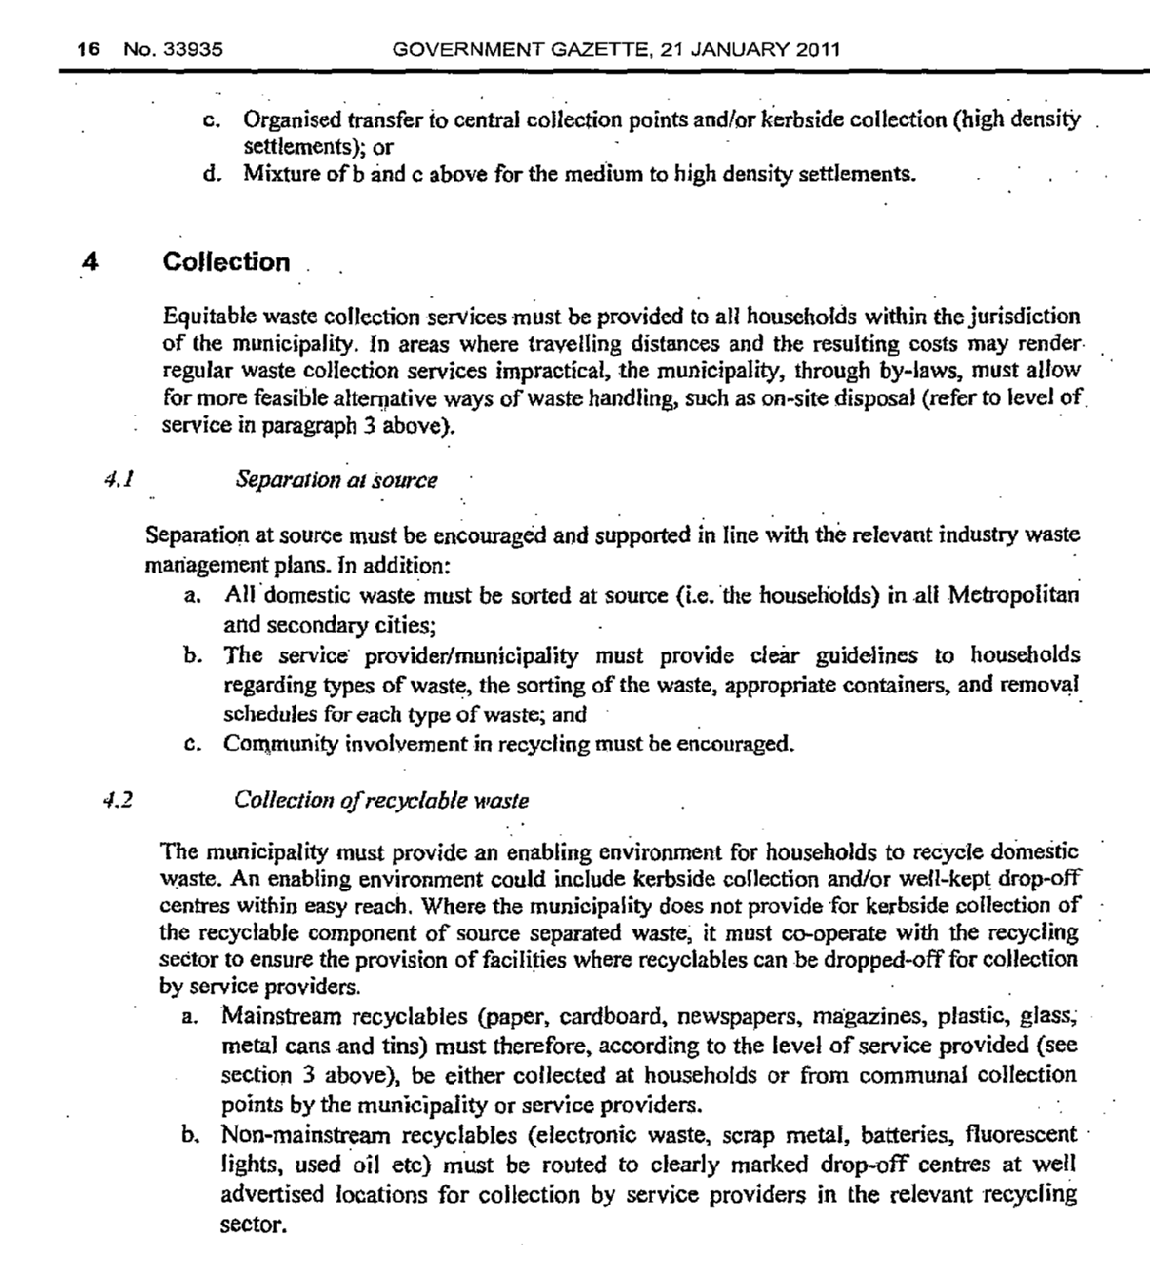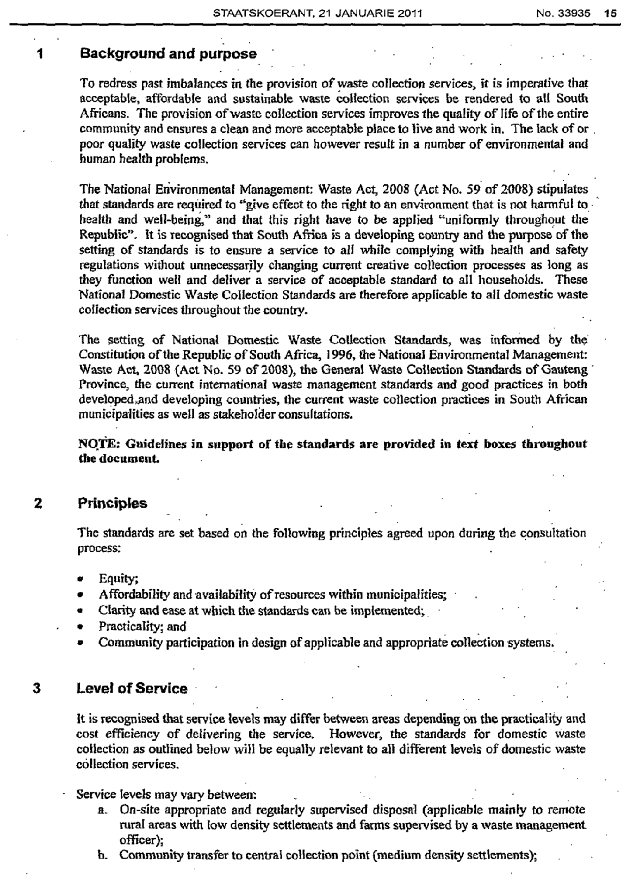
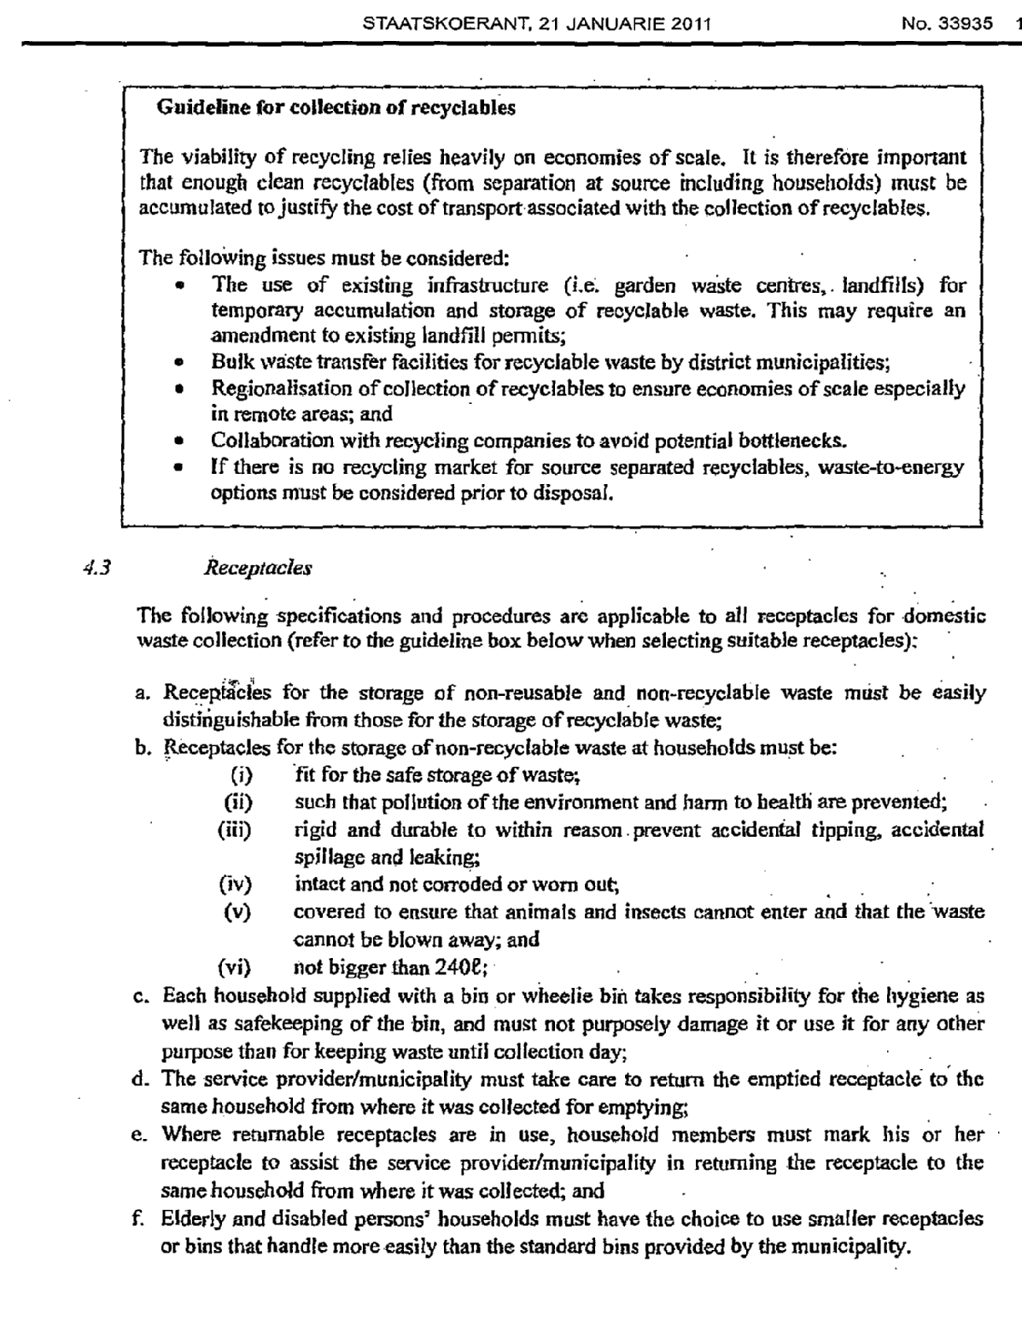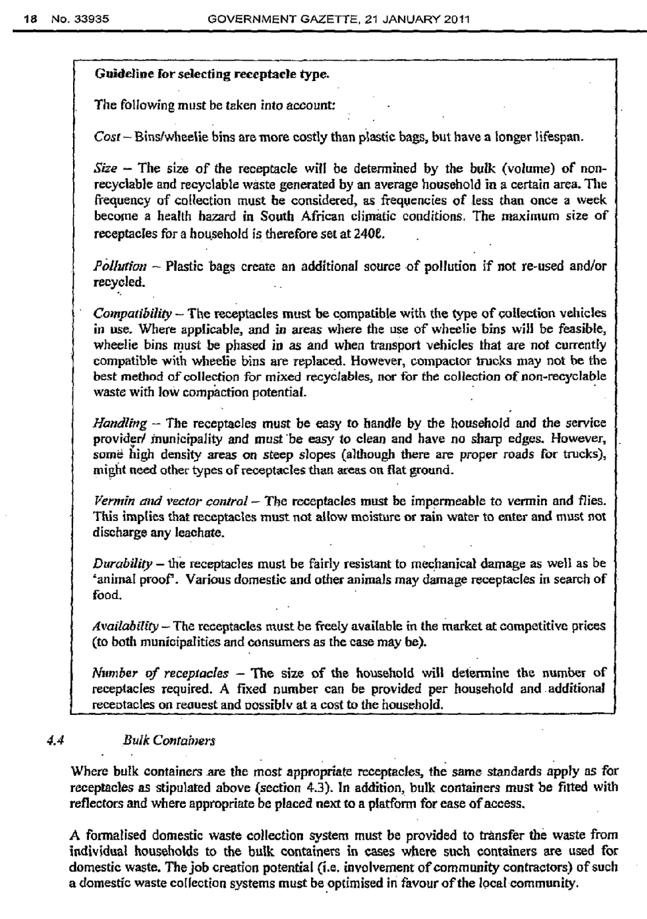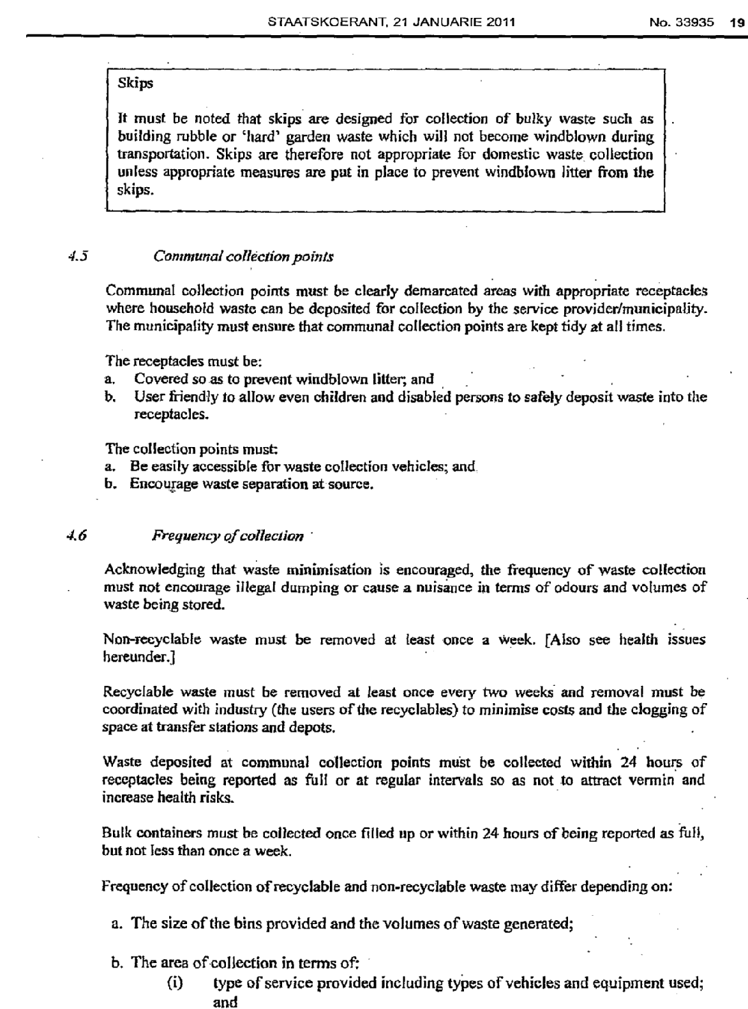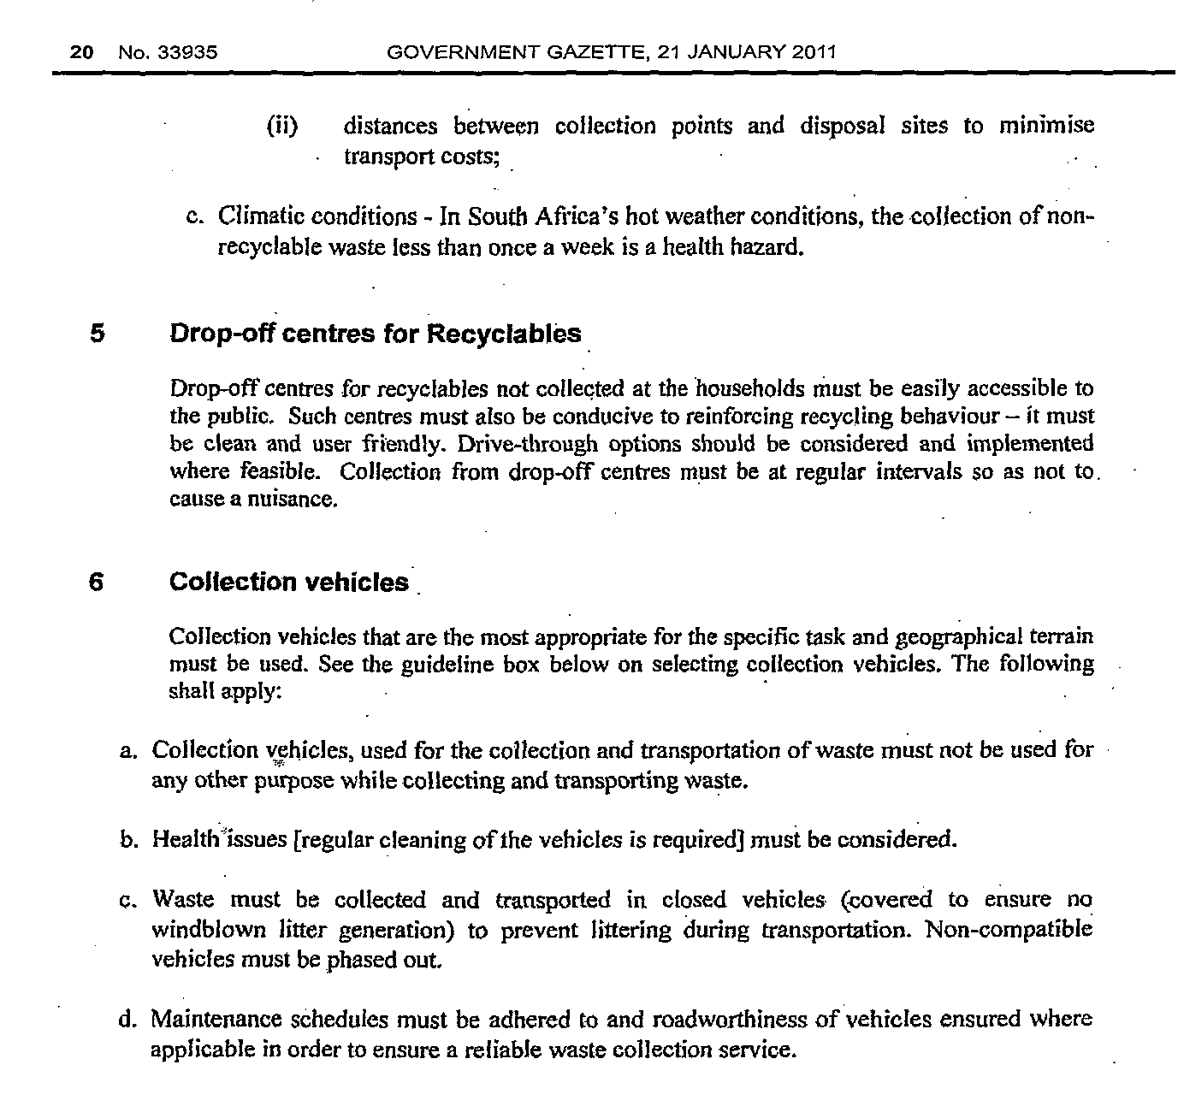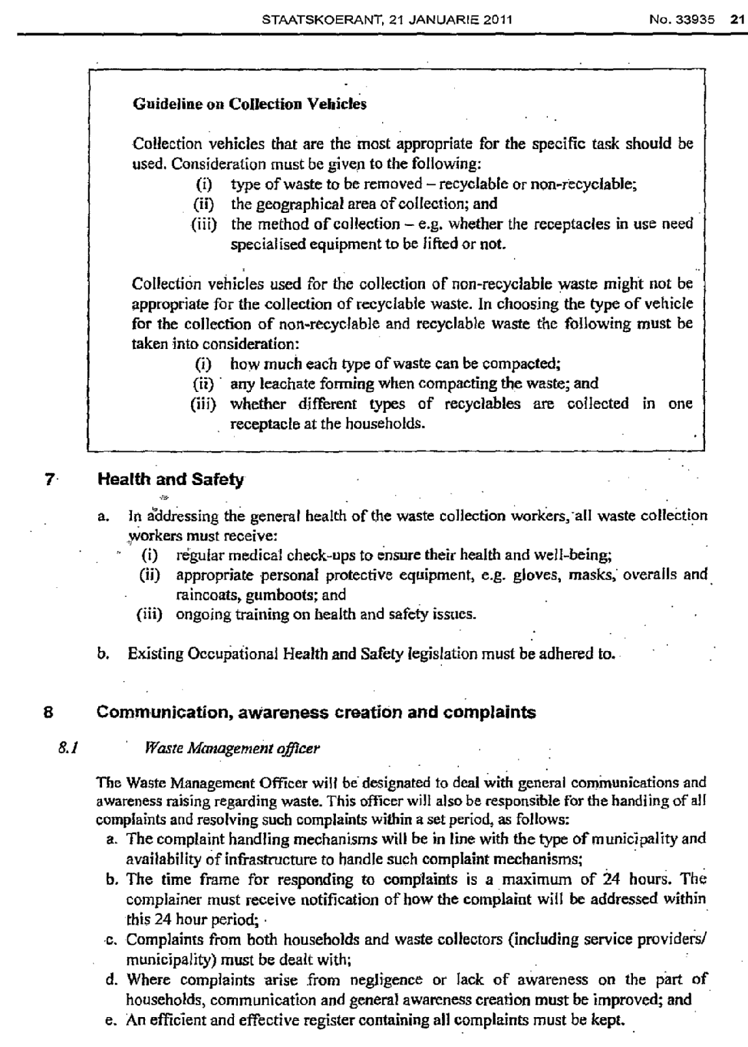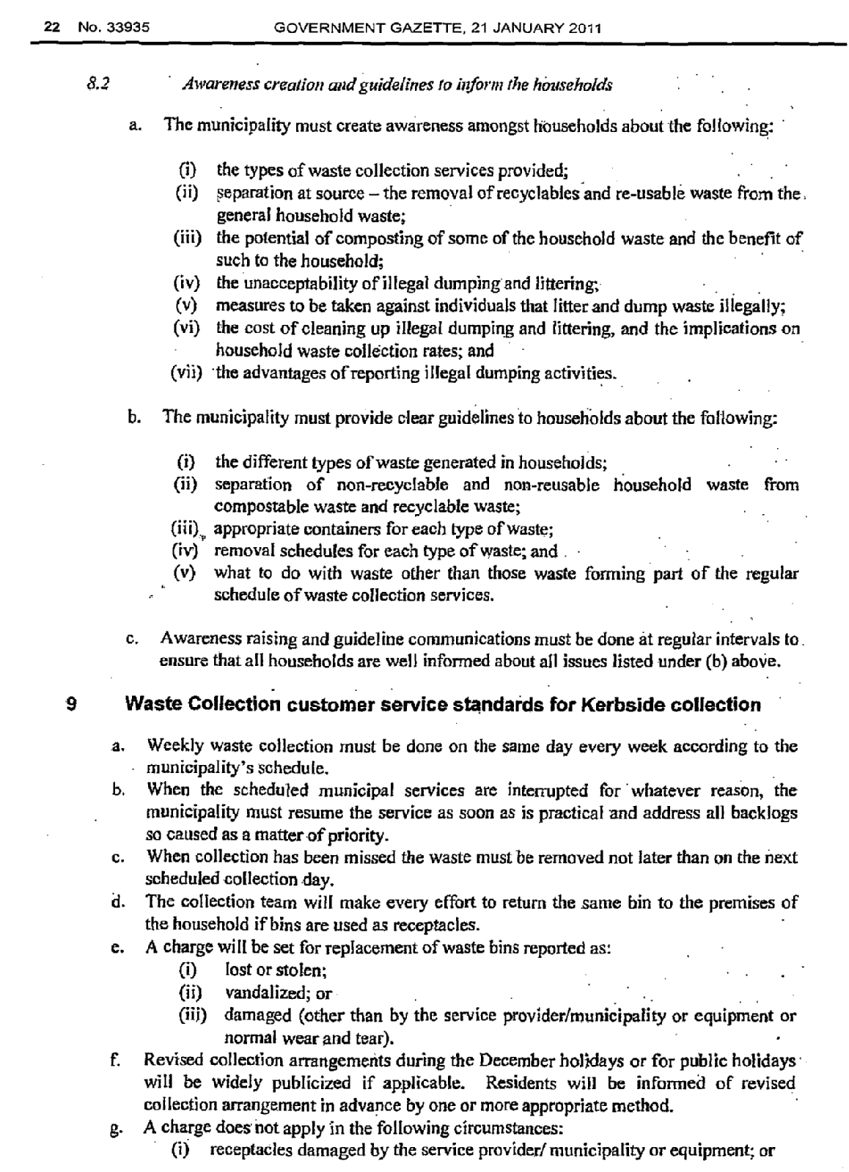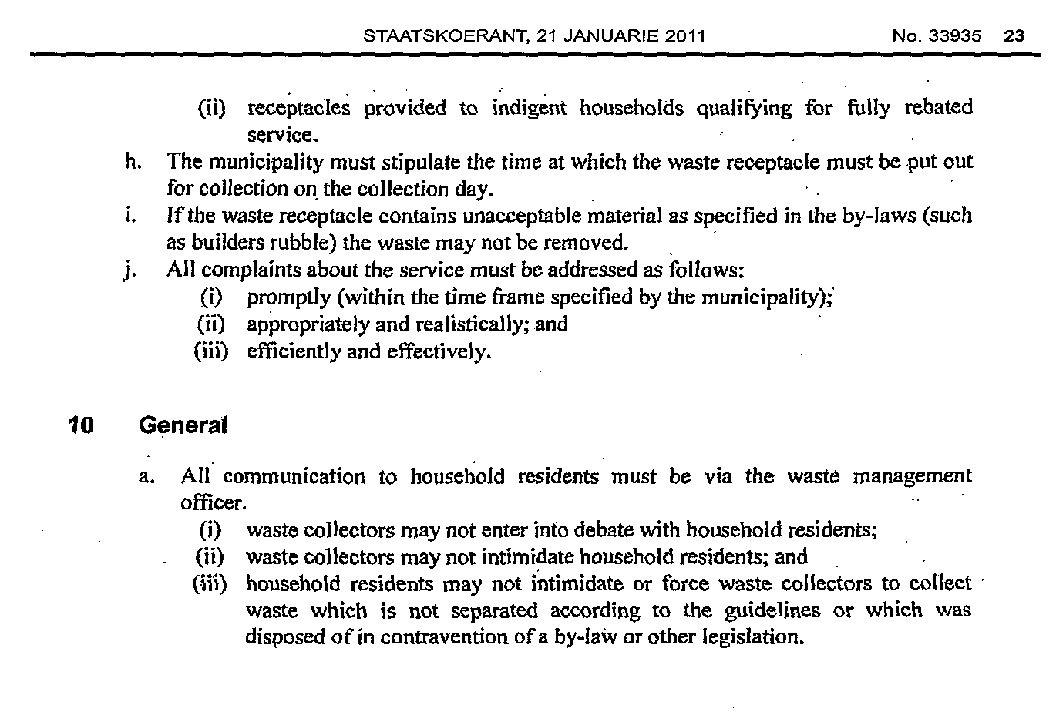
SAFETY AND SECURITY DIVISION

1. Conducted Crime Awareness Campaigns once per quarter.
2. Crime Prevention Against Theft of Council Assets - daily.
3. Community Safety Forum held the Safety and Security Colloquium.
4. Developed Annual Safety Audit
5. Developed Annual Community Safety Plan
6. Maintenance of Access Control Gates ( Morpho) monthly
7. Plan for Joint Opetations Centre for Municipal Events - weekly and as and when needed.

