FOOTER:
- The footer is visible at the bottom of the body of the home page
- It consists of Sitemap, Copyright, Tourism and Contact Us
Internet Explorer
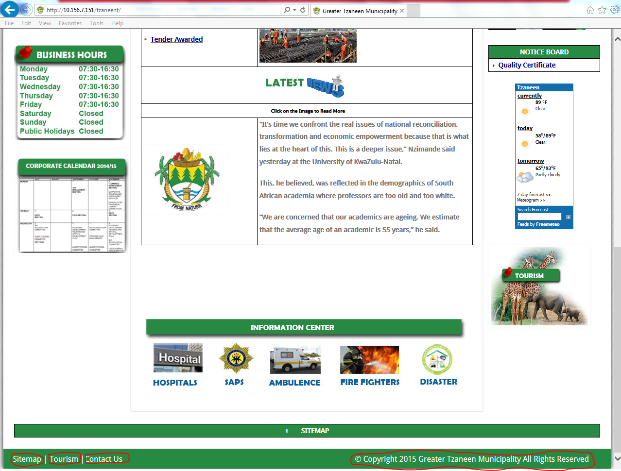

Google Chrome

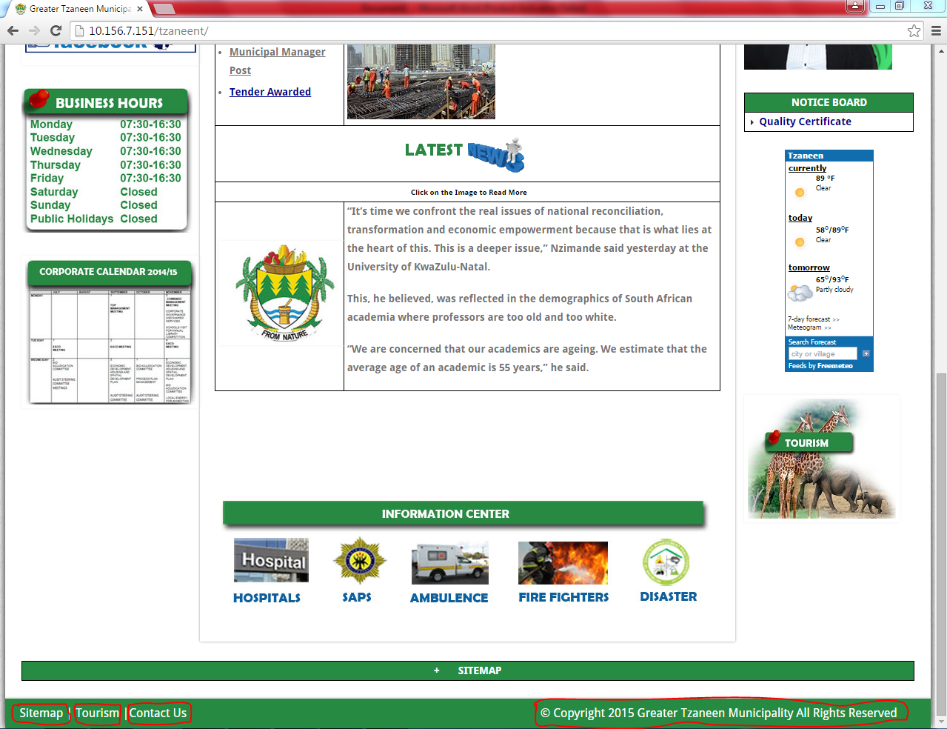

Opera

